SAMPLE PRESS RELEASE
Your Company Logo
<YOUR COMPANY> MADE IT TO THE 2018 LIST OF BEST WORKPLACES™ IN MANUFACTURING

For Release: [insert date]

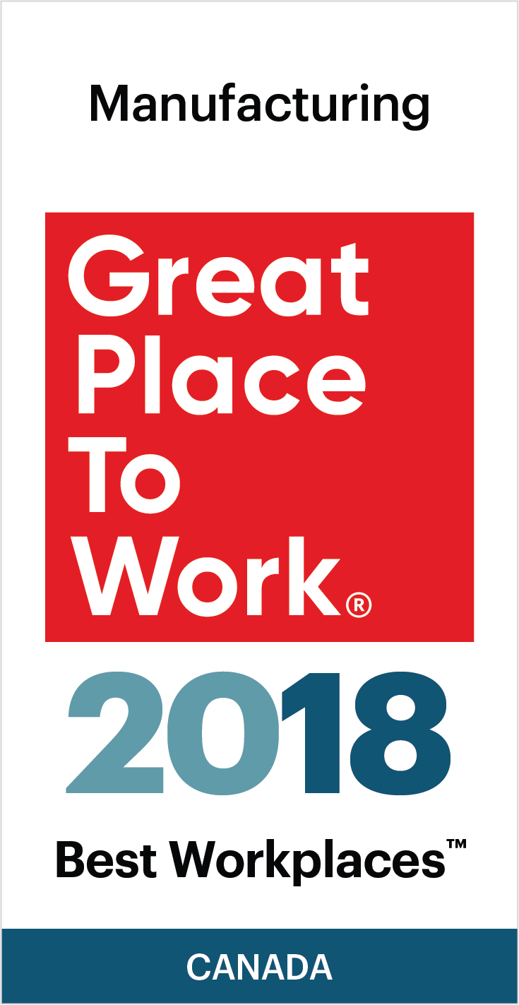
<Your Company> is proud to announce that our organization has been named on the 2018 list of Best Workplaces™ Manufacturing.
<Your Company> received this honour after a thorough and independent analysis conducted by Great Place to Work®.
The list of the 10 Best Workplaces™ in Manufacturing is based on direct feedback from employees of the hundreds of organizations that were surveyed by Great Place to Work®. The data has a 90% confidence and a plus or minus 5% margin of error.
Analysis of the data to compile this list focused on the following considerations:
- For eligibility, organizations must be Great Place to Work Certified™ in the past year, have a minimum of 15 employees, have manufacturing operations in Canada and a minimum 90% positive score to the statement "This is a physically safe place to work".
- GPTW determined the BEST based the overall Trust Index score of eligible organizations.

[Insert a paragraph about your organization’s commitment to be a great workplace] OR [Insert a motivational quotation from your CEO/President.]
About your company:
[Your Company Description]
About Great Place to Work®:
Great Place to Work ® is the global authority on high-trust, high-performance workplace cultures. Through proprietary assessment tools, advisory services, and certification programs, GPTW recognizes the world's Best Workplaces™ in a series of national lists including those published by The Globe & Mail (Canada) and Fortune magazine (USA). Great Place to Work® provides the benchmarks, framework, and expertise needed to create, sustain, and recognize outstanding workplace cultures. Visit us at www.greatplacetowork.ca or find us on Twitter at @GPTW_Canada.

Media contacts:
[insert your company’s PR contact and coordinates]

