SAMPLE PRESS RELEASE
Your Company Logo
YOUR COMPANY NAME IS NAMED TO THE
2018 LIST OF BEST WORKPLACES IN RETAIL AND HOSPITALITY

For Release: [insert date]

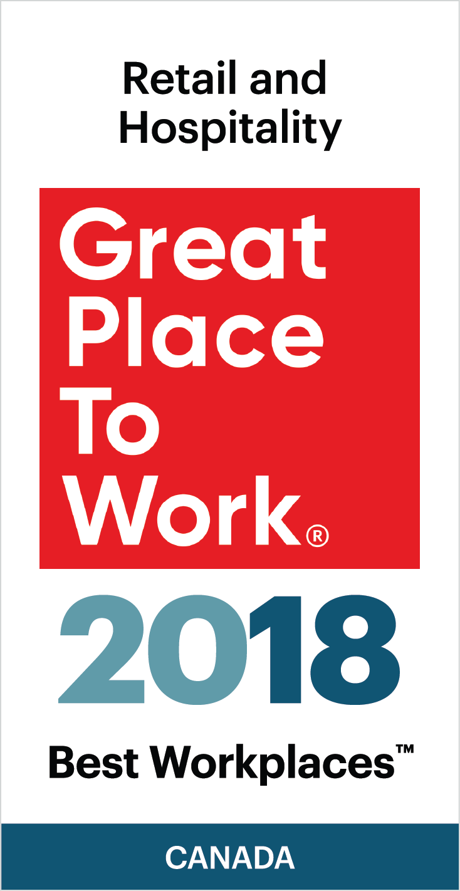
Your Company Name is proud to announce that our organization has been named to the 2018 LIST OF BEST WORKPLACES IN RETAIL AND HOSPITALITY
Your Company Name received this honour after a thorough and independent analysis conducted by Great Place to Work®.
The list of the 20 Best Workplaces in Retail and Hospitality is based on direct feedback from employees of the hundreds of organizations that were surveyed by Great Place to Work®. The data has a 90% confidence and a plus or minus 5% margin of error.
Analysis of the data to compile this list focused on the following considerations:
      - For eligibility, companies must be Great Place to Work™ in the past year, have a minimum of 25 employees, and have Retail or Hospitality as their primary industry.
      - GPTW determined the BEST based the overall Trust Index score of eligible organizations.

Insert a paragraph about your organization’s commitment to being a great workplace culture] OR [Insert a motivational quotation from your CEO/President.
About your company:
[Your Company Description]
About Great Place to Work®:
Great Place to Work ® (GPTW) is the global authority on high-trust, high-performance workplace cultures. Through proprietary assessment tools, advisory services, and certification programs, GPTW recognizes the world's Best Workplaces in a series of national lists including those published by Fortune magazine (USA) and The Globe & Mail (Canada). Great Place to Work® provides the benchmarks, framework, and expertise needed to create, sustain, and recognize outstanding workplace cultures. www.greatplacetowork.ca and @GPTW_Canada

Media contacts:
[insert your company’s PR contact and coordinates]

